**Intro to AI  
Phase 2: Term project mid-status report  
Development results**

# Project Question:

How can a mini Akinator game be designed to accurately identify a character based on user responses, utilizing decision tree-based filtering?

# Introduction:

The aim of this project is to develop a very simple AI, modeled after a vintage game called Akinator-a game where an AI tries to identify a character which the user has in mind by asking various questions that can receive a yes or no answer. In this model, the user's responses filter out the character names using rule-based filtering and may resort to Naive Bayes inference to rank the rest of the candidates for guess based on probability. This way the most probable guess will be formed.

Fundamental notions of AI like decision trees, probabilistic models and handling input from the user get introduced through the project. The focus, however, is more on facilitating smoothness and interactivity of the usage experience so that the system will still hold its ground by assuring effectiveness as the dataset of characters just grows larger and larger.

# Literature Related to the Akinator Game Project

The following literature supports the works for developing a simplified Akinator game based on decision trees for identifying characters, a binary question-answering approach for user interaction, and gamified user experience with a minimal custom dataset.

1. **Biancofiore, G. M., Deldjoo, Y., Di Noia, T., Di Sciascio, E., & Narducci, F. (2024). Interactive Question Answering Systems: Literature Review. ACM Computing Surveys.** *https://dl.acm.org/doi/10.1145/3657637*

This survey gives an extensive overview of the interactive question-answering systems, which essentially work by intermixing the dialogue system with queries in natural language to answer even while dynamically refining their answers. It is about methods for systems that use follow-up questions to resolve ambiguities akin to your Akinator game's yes/no query mechanism to narrow down characters. The paper also surveys methods and data sets for evaluating QA systems working effectively with limited data, hence justifying your use of a small custom dataset. The emphasis on human interaction trends would certainly aid in the gamified UI design of your project, providing ideas for interesting sequences of questions.

1. **Voukelatos, N., & Mylonas, P. (2023). Decision Trees: From Efficient Prediction to Responsible AI. Frontiers in Artificial Intelligence**. *https://www.frontiersin.org/articles/10.3389/frai.2023.1179997/full*

The paper traces the development of decision trees in artificial intelligence from the viewpoint of predictive modelling to being systematized as transparent and interpretable systems. It has a direct correlate with the project as the use of decision trees from this paper refers to filtering a character data set based on binary responses, as presented and spoken of in your second reference. Another relevant stream from this paper concerns decision trees related to AI in games, where interpretability is essential, thus supporting the minimalistic view that is being applied. Also, it informs on the challenges facing scaling decision trees to vast datasets, hence confirming the conscious choice of validating the use of a small custom dataset for simplicity and efficiency.

1. **Rapp, A., Curti, L., & Boldi, A. (2021). The Human Side of Human-Chatbot Interaction: A Systematic Literature Review of Ten Years of Research on Text-Based Chatbots. International Journal of Human-Computer Studies, 151, 102630.** *https://www.sciencedirect.com/science/article/pii/S1071581921000358*

This review summarizes user experiences with text-based chatbots, looking at satisfaction, engagement, and trust: the three key components of your project gamified UI as inspired by the third reference. Whereas your Akinator game works with button inputs of yes or no, the insights provided from a design perspective for engaging yet simple interactions will help you achieve a sleek and user-friendly interface. It highlights the role of minimalistic design in sustaining user interest, which corroborates your project of streamlined gameplay mechanics.

# Achievements and Challenges:

So far, the game has been developed, and the core functionality is operational. The AI model correctly narrows down to a single character based on yes/no responses to a set of predefined questions. The main achievements include:

## Tasks Accomplished

* Implemented the game flow where users answer yes/no questions.
* Filtered through a custom character dataset based on user inputs.
* Successfully narrowed down the possibilities to one or a few characters.

## Challenges faced:

* Dataset Limitation: The small dataset (20 characters) has restricted the variety of questions and responses possible. Expanding the dataset to more characters with different traits will require fine-tuning the question set for better accuracy.
* For each question we can have n! characters, so trying to make fullest use of all the possibilities to make the questions minimal and characters diverse.

## Workarounds and experiments we are doing:

* Expanded the question set to ensure each question eliminates multiple characters, increasing the chances of guessing the right one.
* Added input validation to prompt the user for correct responses, ensuring gameplay isn't interrupted by invalid inputs.

# GitHub Link:

[Akinator Game](https://github.com/Shrutibrahma/Akinator_MindGame)

https://github.com/Shrutibrahma/Akinator_MindGame

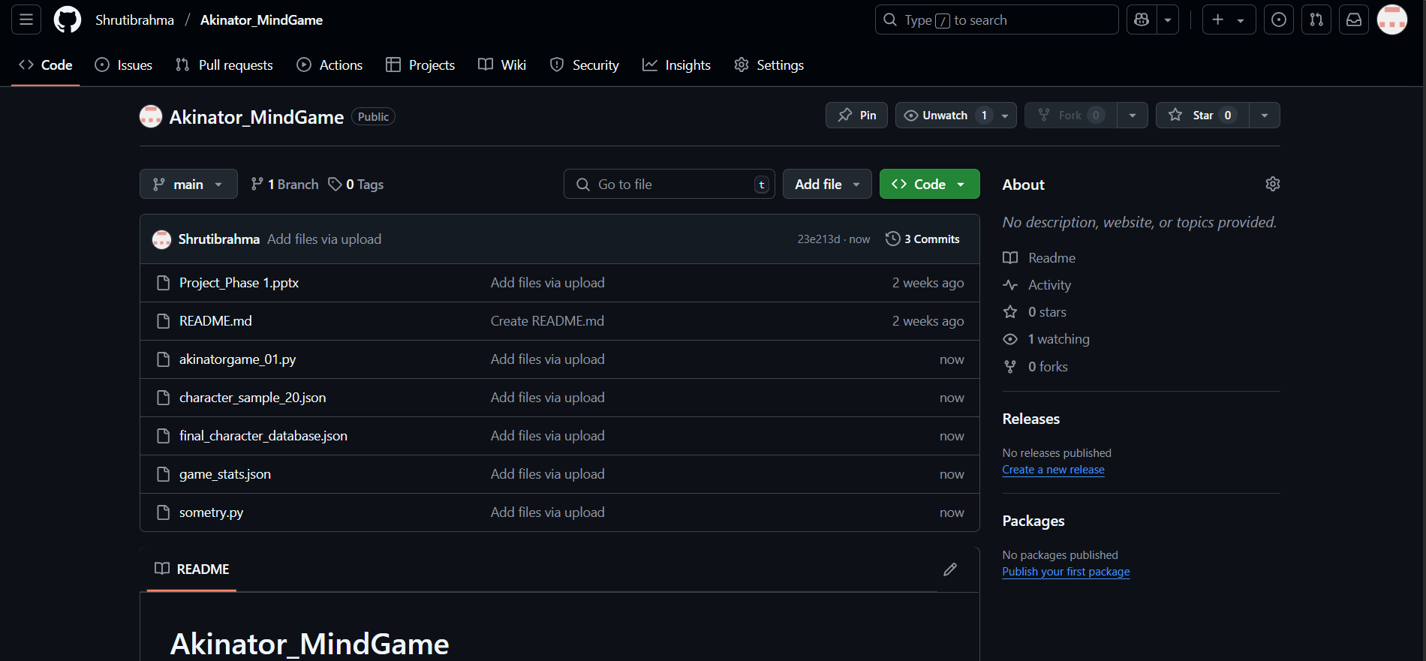

Figure 1 Snippet of GitHub Repository with all uploaded files

# Working of the game so far

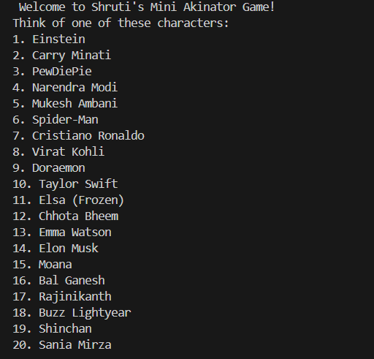

Figure 2 The list of characters user can think of.

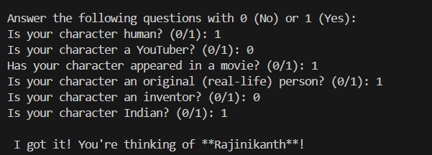

Figure 3 Guessing the character with just yes or no

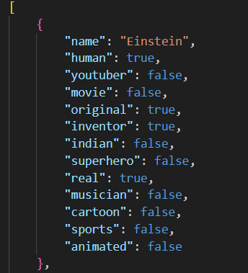 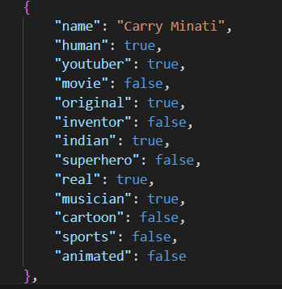

Figure 4 Dataset stored in JSON

# Implementation in Streamlit – App

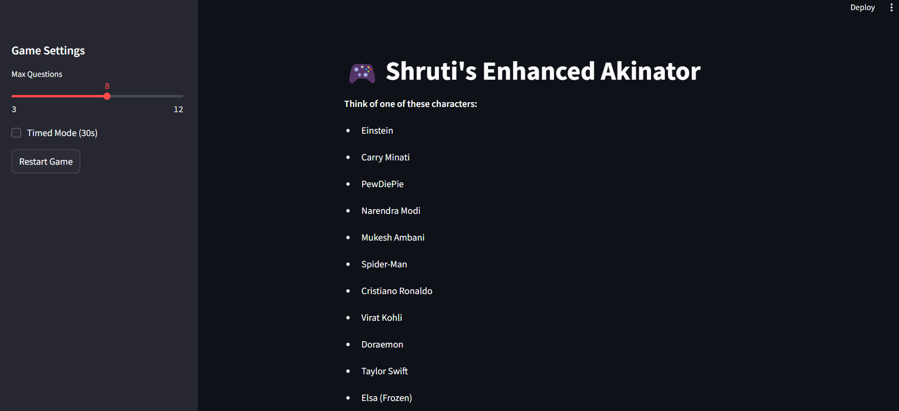

Figure 5 Streamlit Version of the Game

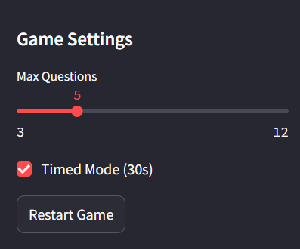 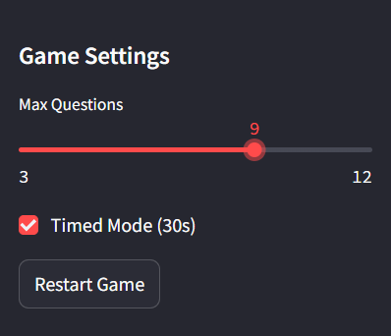

Figure 6 Choose the number of questions and time of the game play.

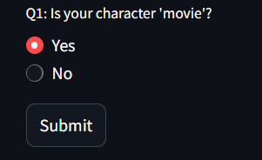 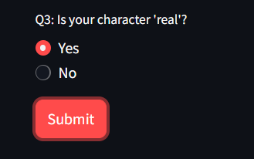

Figure 6 Answer Basic Questions in just Yes or No.